Amazon | OA 2019 | Treasure Island

LEETCODE : https://leetcode.com/discuss/interview-question/347457

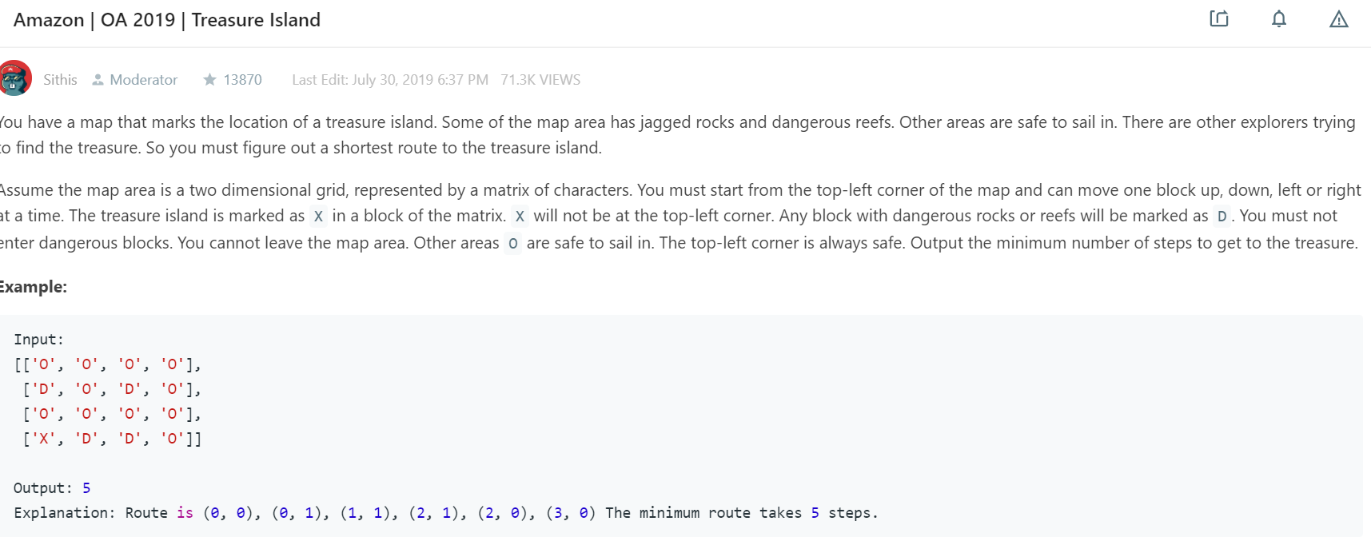

public static int treasureIsland(char[][] island) {

if (island == null || island.length == 0) return 0;

int steps = 0;

Queue<Coordinate> queue = new LinkedList<>();

queue.add(new Coordinate(0, 0));

boolean[][] visited = new boolean[island.length][island[0].length];

visited[0][0] = true;

int[][] dirs = new int[][]{{1, 0}, {-1, 0}, {0, 1}, {0, -1}};

// bfs

while (!queue.isEmpty()) {

int size = queue.size();

for (int i = 0; i < size; i++) {

Coordinate coordinate = queue.poll();

int x = coordinate.x;

int y = coordinate.y;

if (island[x][y] == 'X') return steps;

for (int[] dir : dirs) {

int newX = x + dir[0];

int newY = y + dir[1];

if (newX >= 0 && newX < island.length && newY >= 0 && newY < island[0].length &&

island[newX][newY] != 'D' && !visited[newX][newY]) {

queue.add(new Coordinate(newX, newY));

visited[newX][newY] = true;

}

}

}

steps++;

}

return 0;

}

public static void main(String[] args) {

char[][] island = new char[][]{

{'O', 'O', 'O', 'O'},

{'D', 'O', 'D', 'O'},

{'O', 'O', 'O', 'O'},

{'X', 'D', 'D', 'O'}

};

int result = AmazonTreasureIsland.treasureIsland(island);

System.out.println(String.format("%s (expect 5)", result));

}

static class Coordinate {

int x;

int y;

Coordinate(int x, int y) {

this.x = x;

this.y = y;

}

}